**Ver paquetes disponible en los repositorios públicos**

sudo apt-cache search php

sudo apt-cache search mysql

sudo apt-cache search php | grep mysql

sudo apt-cache search mysql | grep php

**PHP**

sudo apt-get install php

sudo apt-get install php-mysql

**Testear**

cd /var/www/html

nano infophp.php

<?php

phpinfo();

?>

ps aux | grep php

ps aux | grep mysql

**MYSQL**

sudo apt-get install mysql-server

sudo mysql

sudo mysql -u root -p

CREATE DATABASE wordpress;

USE wordpress;

CREATE USER 'user'@'localhost' IDENTIFIED BY 'password';

GRANT ALL PRIVILEGES ON wordpress.* TO 'user'@'localhost';

FLUSH PRIVILEGES;

**WORDPRESS**

cd /var/www/html

sudo wget <https://wordpress.org/latest.zip>

sudo unzip latest.zip

sudo chown -R www-data:www-data /var/www/html/wordpress

sudo nano /etc/apache2/sites-available/wordpress.conf

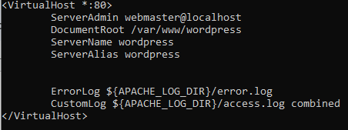

sudo a2ensite wordpress.conf

sudo apache2ctl configtest

sudo systemctl reload apache2

sudo systemctl restart apache2

<http://192.168.1.63/wordpress/>

idioma

detalles de la base de datos creada

wordpress

user

password

detalles del sitio

ejercicio

userweb

X(gGML1HsQsy#9mmF^

[jo.gonzalez@aulanz.net](mailto:jo.gonzalez@aulanz.net)

<http://192.168.1.63/wordpress/wp-admin>